In algebra linear equations of a straight line use the formula y = mx + c where x and y are the x and y axis variables, c is the intercept of the y axis and m is the gradient of the line. The equation can then be reshuffled to find a coordinate as follows: (y – y1) = m(x – x1). This can also be reshuffled to isolating the m on one side and having the y divided by the x on the other side should you need to calculate m. Graphs can also be drawn using these equations for a better understanding of how each aspect of the formula affects how the graph is drawn.

To draw the graph with the information provided, I will use the dollar amounts as the y axis coordinate and the days of the 3 months as the x axis coordinates. Thus I will have 3 lines with 2 points each resulting in 6 sets of coordinates as listed below.

(0, 10) first day of first month and $10

(30, 12) last day of first month and $12

(31, 12) first day of second month and $12

(58, 9) last day of second month and $9

(59, 9) first day of third month and $9

(90, 15) last day of third month and $15

I can now use these coordinates to calculate the gradient of each of the 3 lines using the two sets of coordinates given for each line, the start and end of each of the three months to calculate the gradient that will indicate the price change over time.

First month gradient:

M = (y2 – y1)/(x2 – x1)

M = (12 - 10)/(30 - 0)

M = 2/30

M = 1/15

Second month gradient:

M = (y2 – y1)/(x2 – x1)

M = (9 - 12)/(58 - 31)

M = (-3/27)

M = -1/9

Third month gradient:

M = (y2 – y1)/(x2 – x1)

M = (15 - 9)/(90 - 59)

M = 6/31

Next I can calculate the full equation of each line so I can draw it on a graph by replacing back in the gradient I managed to calculate for each line.

First month equation:

(y – y1) = m(x – x1)

(y – 10) = 1/15(x – 0)

Y – 10 = 1/15x

Y = 1/15x + 10

Second month equation:

(y – y1) = m(x – x1)

Y – 12 = -1/9(x – 31)

Y = -1/9x + 31/9 + 12

Y = -1/9x + 139/9

Third month equation:

(y – y1) = m(x – x1)

Y – 9 = 6/31(x – 59)

Y = 6/31x – 354/31 + 9

Y = 6/31x – 75/31

Now, mapped out onto a graph below are the 3 line equations: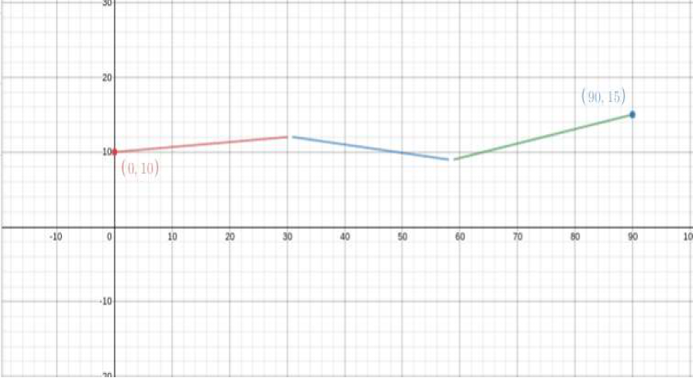

Now, to answer the questions provided:

The graph shows the price increase is not a straight line but rather 3 lines that connect together.

The first naïve view of the situation would be to see that there is a month by month change to the price, either increasing or decreasing.

A simple function would hold up depending on what information you find valuable. If you just want to note the stock price increase or decrease, then yes. If you need more information, then no.

The simplest function to represent this is the linear function y = mx + c.

The models allow you to predict the stock behaviour for the next consecutive month yes, however how accurate it will be is unpredictable as it would simply be an average over the previous 3 months.

Total Words (577)